Visvesvaraya Technological University
Belagavi, Karnataka-590 018
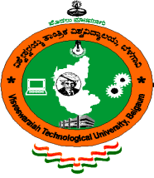

A MINI PROJECT REPORT

On

‘FEST MANAGEMENT SYSTEM’

Submitted

In partial fulfilment requirments for the award of the Degree

of

BACHELOR OF ENGINEERING

IN

INFORMATION SCIENCE AND ENGINEERING

by

MOKSHA SHETTY 4NM17IS062
RAKSHITHA B R 4NM17IS077

Under the Guidance of

Abhishek S. Rao

_{Assistant Professor}

Department of Information Science and Engineering


